Command Pattern
# Source: AI Source: Provided by: [Data Path: Persons Table -> ID Column: 1, Name_En Column: Motasem Essam] -> From: [ChatGPT] on [1/23/2026]
The Command Pattern encapsulates a request as an object, allowing you to parameterize clients with different requests, queue or log them, and support undo/redo operations.
👉 Think of it like a remote control: each button (command) triggers a specific action without knowing how it’s implemented.

🔑 Key Points
# Source: AI Source: Provided by: [Data Path: Persons Table -> ID Column: 1, Name_En Column: Motasem Essam] -> From: [ChatGPT] on [1/23/2026]
• Encapsulates requests into objects
• Decouples sender (invoker) from receiver (executor)
• Supports undo/redo, logging, and queuing
• Promotes loose coupling

❌ Bad Example
# Source: AI Source: Provided by: [Data Path: Persons Table -> ID Column: 1, Name_En Column: Motasem Essam] -> From: [ChatGPT] on [1/23/2026]
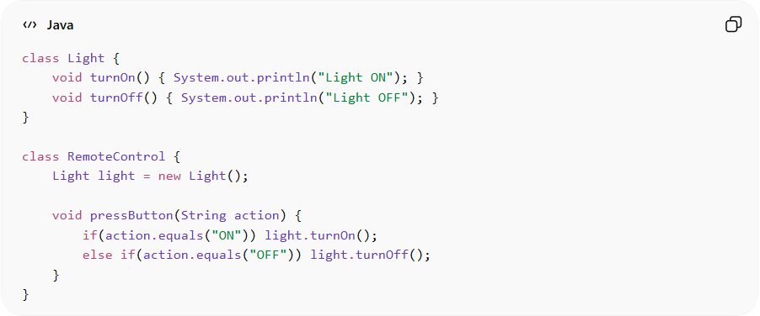
class Light {
void turnOn() { System.out.println("Light ON"); }
void turnOff() { System.out.println("Light OFF"); }
}

class RemoteControl {
Light light = new Light();

void pressButton(String action) {
if(action.equals("ON")) light.turnOn();
else if(action.equals("OFF")) light.turnOff();
}
}
Problems:
• Tight coupling between remote and device
• Uses conditional logic
• Hard to extend with new commands

✅ Good Example
# Source: AI Source: Provided by: [Data Path: Persons Table -> ID Column: 1, Name_En Column: Motasem Essam] -> From: [ChatGPT] on [1/23/2026]
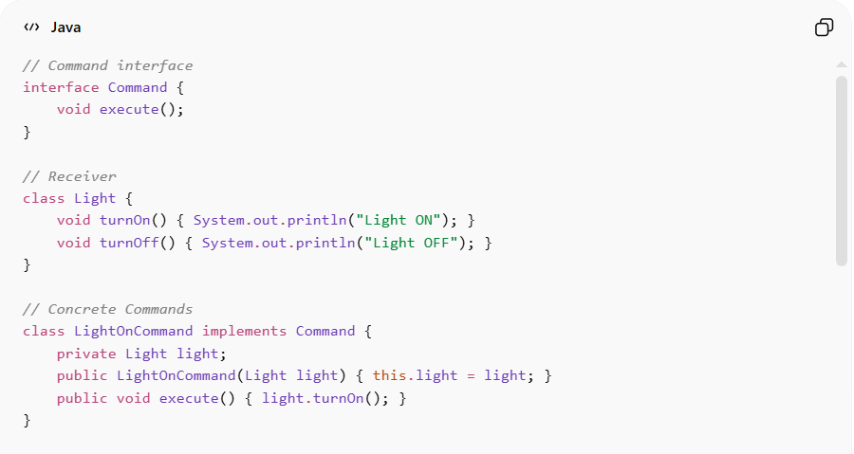
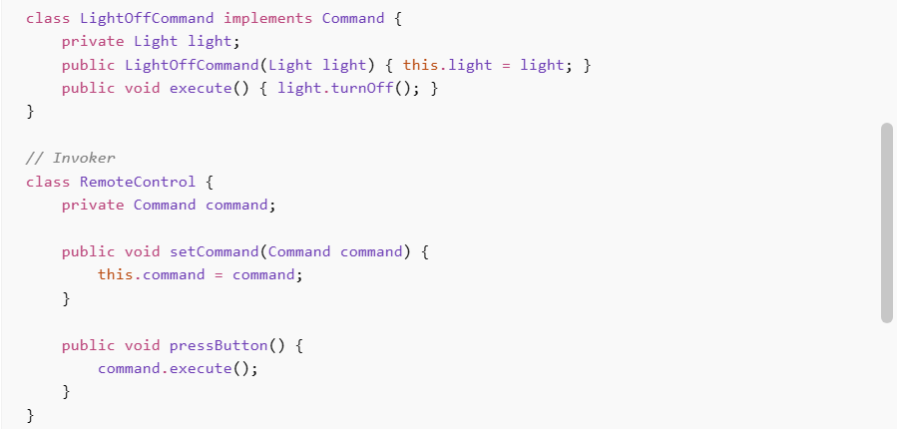
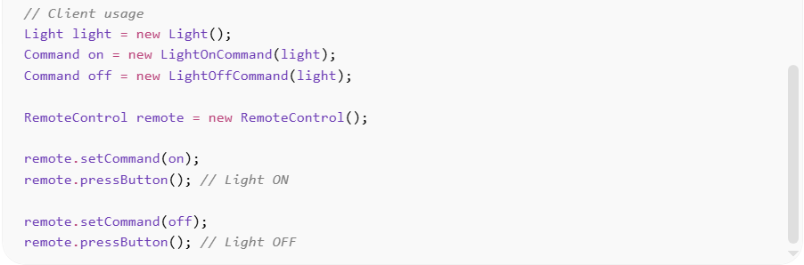
// Command interface
interface Command {
void execute();
}

// Receiver
class Light {
void turnOn() { System.out.println("Light ON"); }
void turnOff() { System.out.println("Light OFF"); }
}

// Concrete Commands
class LightOnCommand implements Command {
private Light light;
public LightOnCommand(Light light) { this.light = light; }
public void execute() { light.turnOn(); }
}

class LightOffCommand implements Command {
private Light light;
public LightOffCommand(Light light) { this.light = light; }
public void execute() { light.turnOff(); }
}

// Invoker
class RemoteControl {
private Command command;

public void setCommand(Command command) {
this.command = command;
}

public void pressButton() {
command.execute();
}
}

// Client usage
Light light = new Light();
Command on = new LightOnCommand(light);
Command off = new LightOffCommand(light);

RemoteControl remote = new RemoteControl();

remote.setCommand(on);
remote.pressButton(); // Light ON

remote.setCommand(off);
remote.pressButton(); // Light OFF
Benefits:
• Decouples invoker from receiver
• Easy to add new commands
• Supports undo/redo and logging
• Promotes flexible and extensible design

⚡ Advantages
# Source: AI Source: Provided by: [Data Path: Persons Table -> ID Column: 1, Name_En Column: Motasem Essam] -> From: [ChatGPT] on [1/23/2026]
• Eliminates conditional logic
• Supports undo/redo operations
• Enables command queuing and scheduling
• Improves code flexibility and maintainability

⚠️ Disadvantages
# Source: AI Source: Provided by: [Data Path: Persons Table -> ID Column: 1, Name_En Column: Motasem Essam] -> From: [ChatGPT] on [1/23/2026]
• Increases number of classes (one per command)
• Can add complexity for simple operations
• May require extra effort to implement undo functionality

🛠️ Use Cases
# Source: AI Source: Provided by: [Data Path: Persons Table -> ID Column: 1, Name_En Column: Motasem Essam] -> From: [ChatGPT] on [1/23/2026]
• GUI buttons and menu actions
• Remote control systems (TV, smart home)
• Task queues and job schedulers
• Undo/Redo systems (text editors, IDEs)

